Problem Time: 90 min

Snapshots:

calc_interest function calculates the interest due, if the balance is less than or equal to 1000 the interest is 1.5% on the total balance but if the balance is greater than 1000$ the interest is 1.5% on the first 1000$ and 1% on any amount over that then return the interest variable as a double value.

calc_total_amount function calculates the total amount due which simply is the sum of the balance and the interest, so it just simply returns the result of that operation.

calc_min_payment function calculates the minimum payment for the account, so the rule is if the total amount due is less than or equal to 10$ the minimum payment, in this case, is equal to the total amount due otherwise it is the greater value between 10$ and 10% of the total amount due after calculating it just return it as a double value.

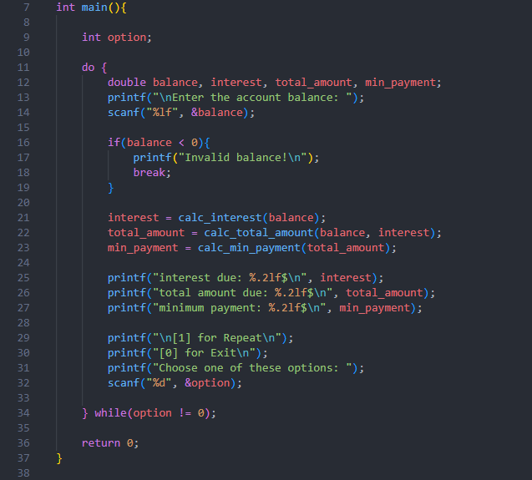

in the main function, we will use a loop to let the user repeat the program as he wants by prompting the user to type 1 for repeat or 0 for exit inside the loop we will ask the user for a balance and if the value of it is negative we will terminate the program with a message to the user otherwise we will use our functions to calculate the needed values and print them.

Test cases:

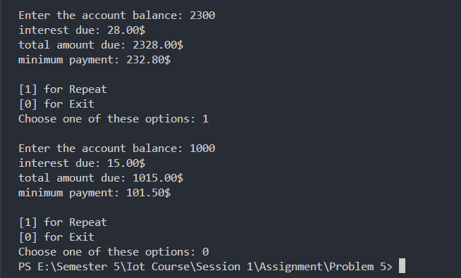

here we first input the balance (2300$ for ex.) and then it will print the values we need then we will input 1 for repeat and input another balance (1000$ for ex.) and also print the needed values then we input 0 to exit the program.

Algorithm:

Step 1: Read the balance from the user

Step 2: Check that the balance is positive value if not terminate the program with a message to the user telling him that the balance is invalid

Step 3: Call our function to calculate needed values

Step 4: Print this information to the user and ask him if he want to repeat or exit

NB: the program will continue running until the user input 0 in the list of options